Name: Tran Khanh Tai
ID: ITITIU21300
Lab 6 Practice
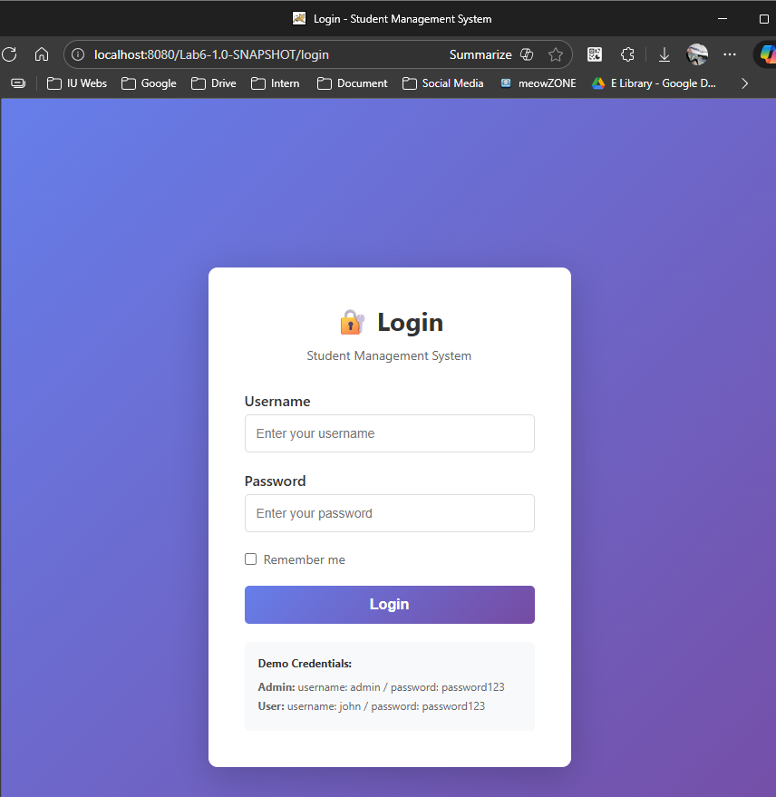
This is the login page when we try to access the web page.
Here we have 2 account to login to this web.

For admin account:
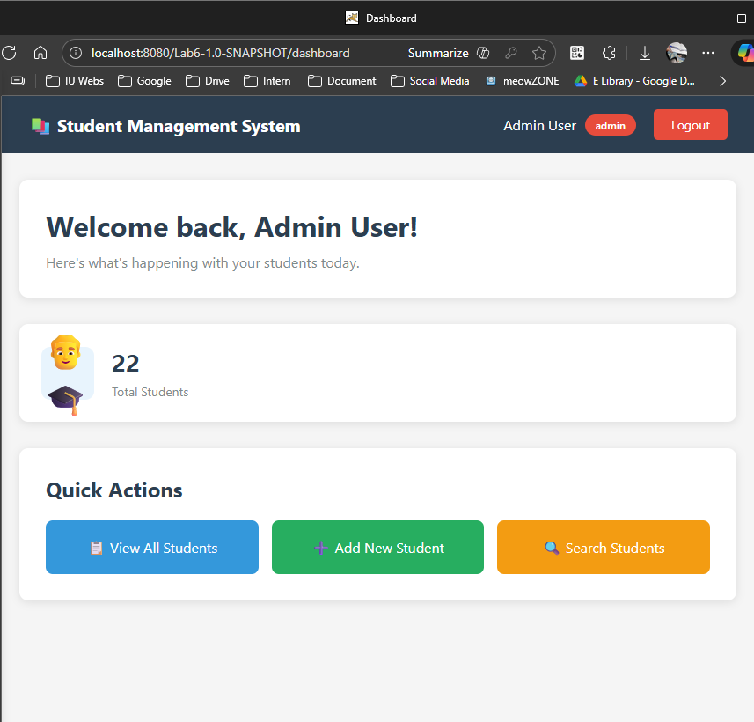
Here is the dashboard of admin:
+ Admin can view the list of students and the number of students in the list (here we have 22 students in the database)
+ Add student
+ Search students

List all students:
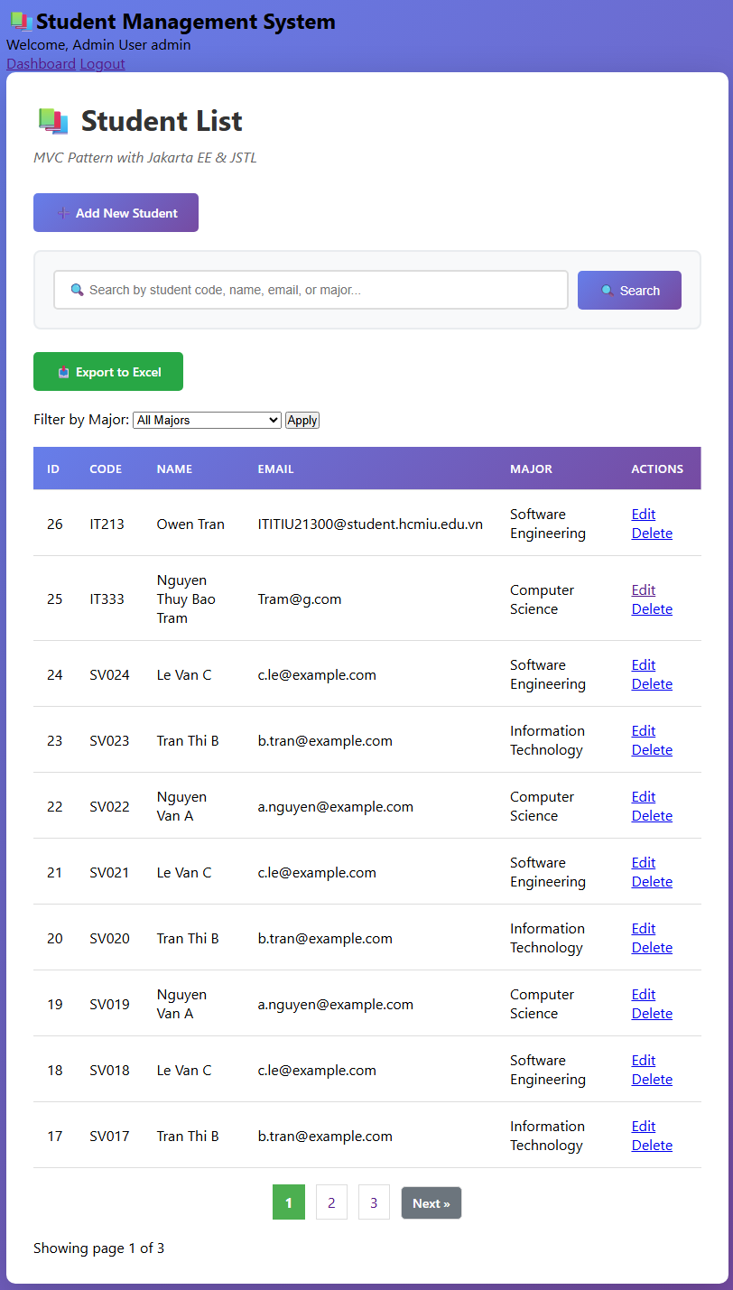
In the student list, admin can Edit or Delete the student information.
For User accessing:
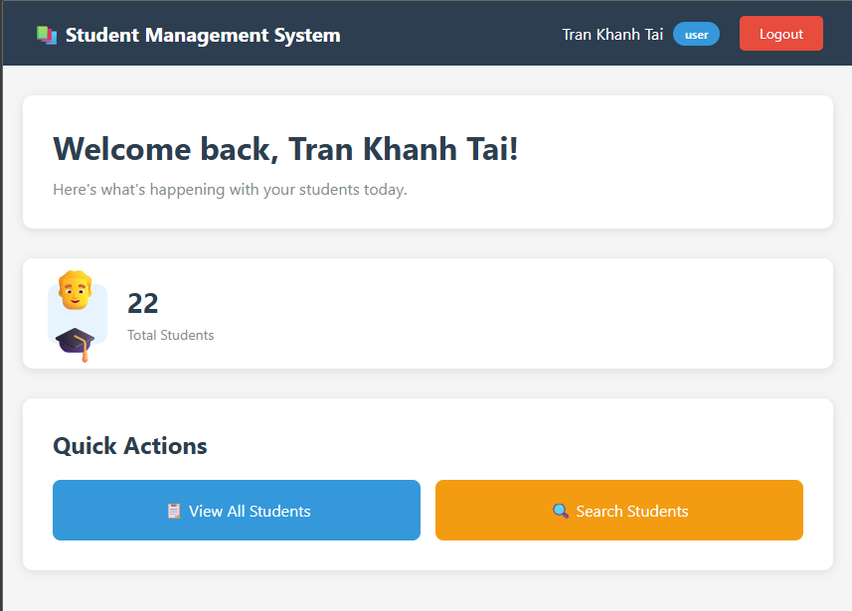
After login, we go to the dashboard page, but the User can’t Add new student like Admin, it just can view all students and search student.
And the User also can’t edit or delete the information of the student in the list like admin
It just can Search student by ID, Code, Name, or Email.
